Installation Guide

|  |  |
| --- | --- |
| Project Title | User Request Management |
| Project Code | FR2018.05 |
| Client | Freelancer |
| Credit | Hai Nguyen / KAIKO VIETNAM |

|  |  |  |  |  |
| --- | --- | --- | --- | --- |
| Created Date | Version | Modified Date | Created By | Updated By |
| May/23/2018 | Draft inital | N/A | Hai Nguyen | N/A |
|  |  |  |  |  |
|  |  |  |  |  |
|  |  |  |  |  |

# Description

This project provides the method to create the request based on SharePoint platform. All requests are stored in the list that categorized by status and summarize in the dashboard.

# Scope

This is internal project for specific client to use. It’s not publicly on the internet or shared with any user.

# Installation

## Requirement

This solution is supported for SharePoint on-premise (2013/2016) and SharePoint Online.

Cross-browser is applied to all as SharePoint platform.

## Package

This solution is packaged as wsp and can be deployed as farm solution or sandbox solution.

## Deploy

1. Open SharePoint Root Site Collection
2. Click on  icon on the top right conner -> then click Site Settings
3. Go to Solutions Gallery under Web Designer Gallery  
   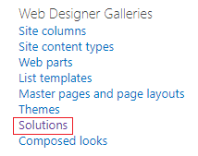
4. Upload the package by click on Upload Solution button on the ribbon  
   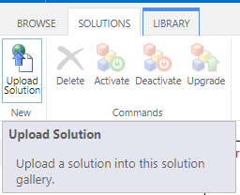
5. Select location to store the package and select the package  
   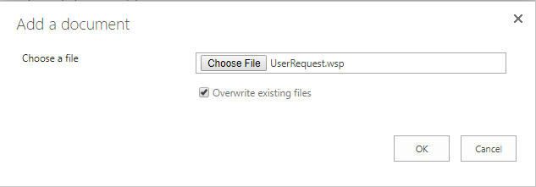
6. Click OK. The new windows will show as below  
   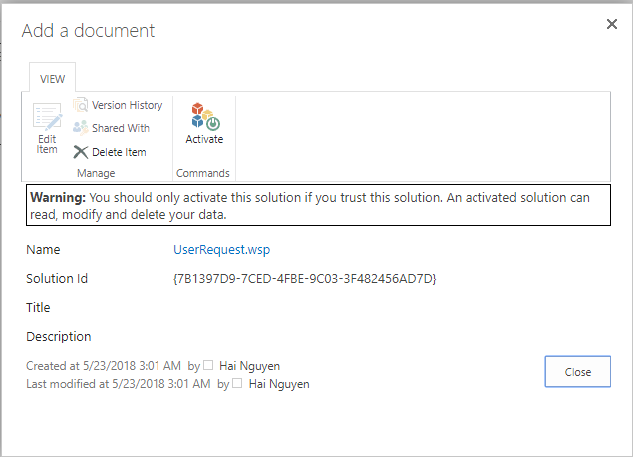
7. Click Activate button on the Ribbon to active the feature.
8. Go to home page of Root Site Collection
9. Click on  on the top right conner -> click on Site Contents
10. Scroll down to sub site section and click New Subsite  
    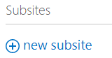
11. The new form to create the new sub site is shown  
    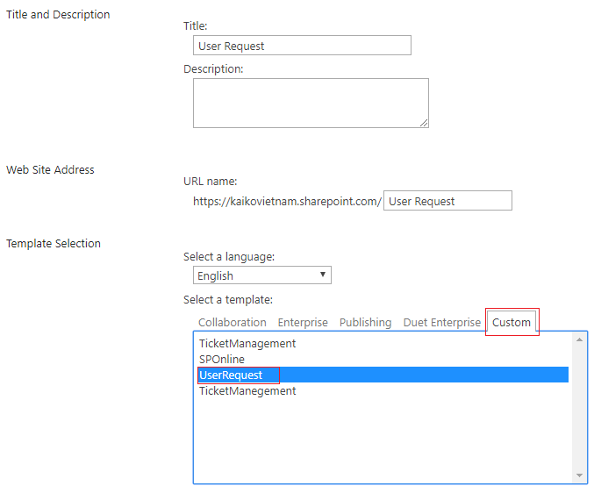
12. Enter the site name and site url. Select the Custom template on the Custom tab then select the template with named “UserRequest”. All other properties are as default. Click Create button.
13. After done, open the site.